# RIASSUNTO

## **Introduction**

It is a convenient practice, to base prediction on models with a finite dimensional set of parameters. Under the Bayesian paradigm inference builds on the posterior distribution of these parameters given the observed data. However, there are problems where inference under the simplified model can lead to misleading decisions and inference. Indeed, **restriction to a parametric family can mislead investigators into an inappropriate illusion of posterior certainty**. Honest quantification of uncertainty is less important when the goal is to report posterior means $E(G| y),$ but could be critical if either the primary inference goal is to characterize this uncertainty or the goal is prediction, if the probability model is part of a decision problem, or if the nonparametric model is part of a larger encompassing model.This need leads to introduce **infinite dimensional families of probability models**. Priors on such families are known **as nonparametric Bayesian (BNP) priors.**

For example, consider a density estimation problem, with observed data $y_{i}∼G,i=1,...,n$. Inference under the Bayesian paradigm requires a completion of the model with a prior for the unknown distribution G. BNP model: prior p(G) = probability model for the infinite dimensional G. A related application of BNP priors on random probability measures is for random effects distributions in mixed effects models.

Another important class of BNP priors is priors on unknown functions, for example a prior p(f) for the unknown mean function f(x) in a regression model $y_{i}=f\left(x_{i}\right)+ε_{i}$.

## **2. Density Estimation**

### 2.1 Dirichlet Process (Mixture) Models

**Leggere Dirichlet process (DP) dagli appunti AIM (Capitolo 9. Bayesian nonparametric model p. 209)**

Qua sotto trovate le cose più importanti

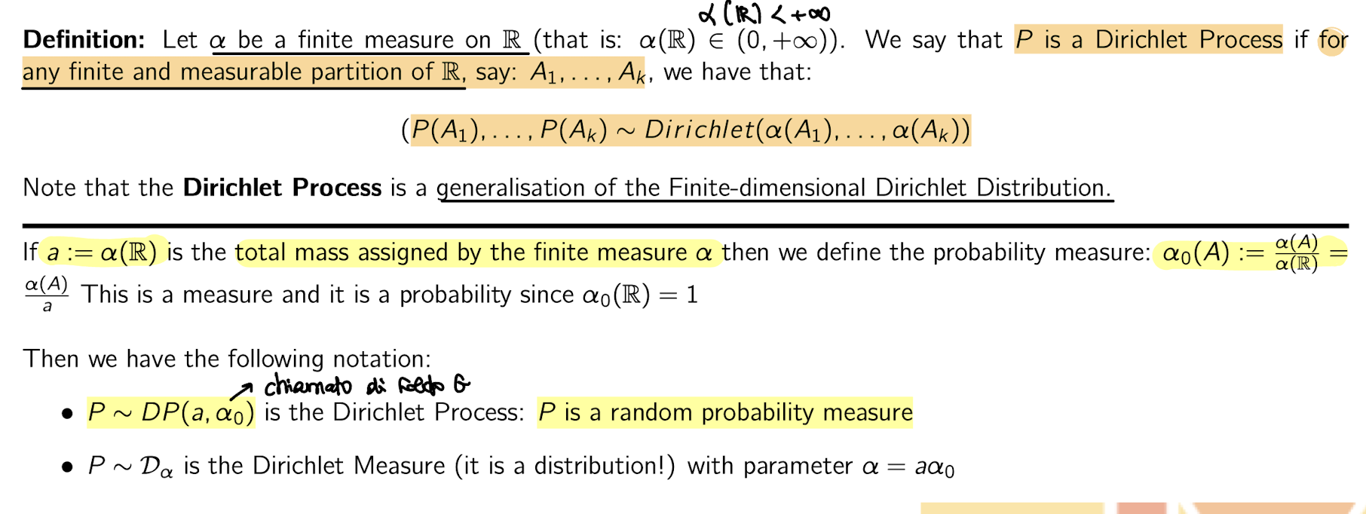

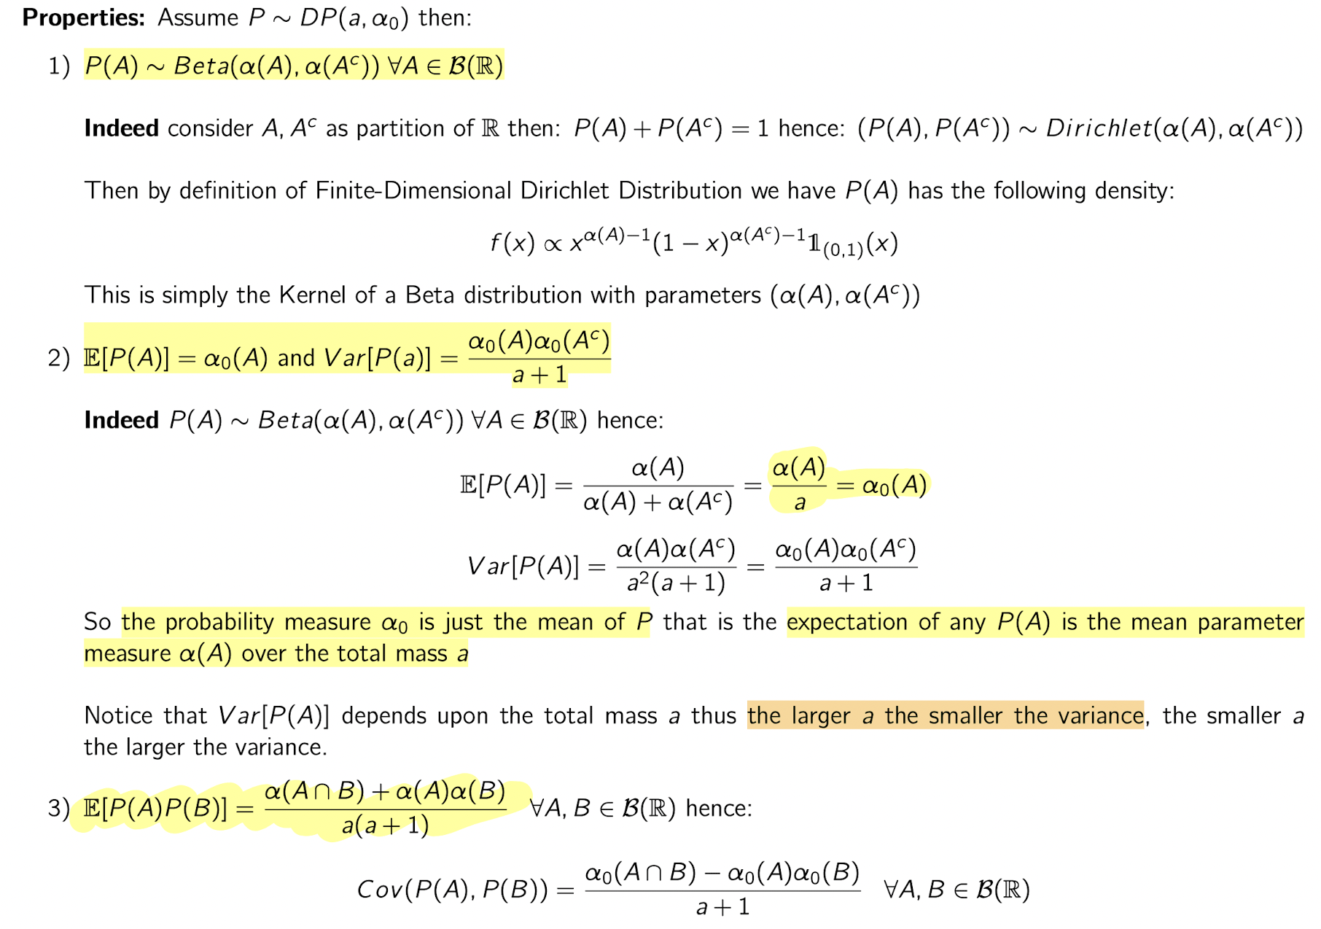

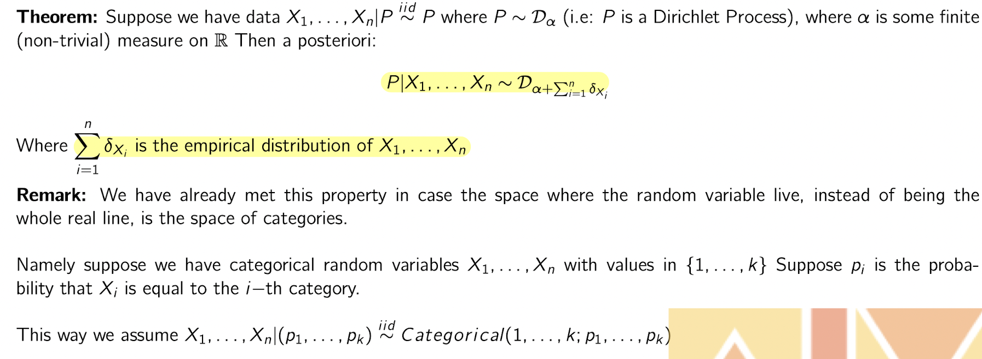

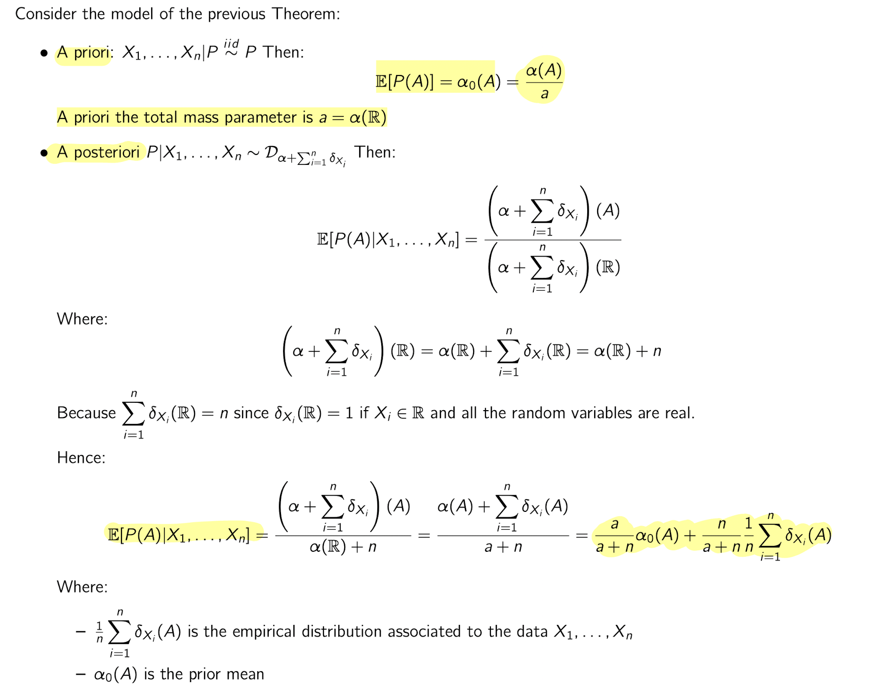

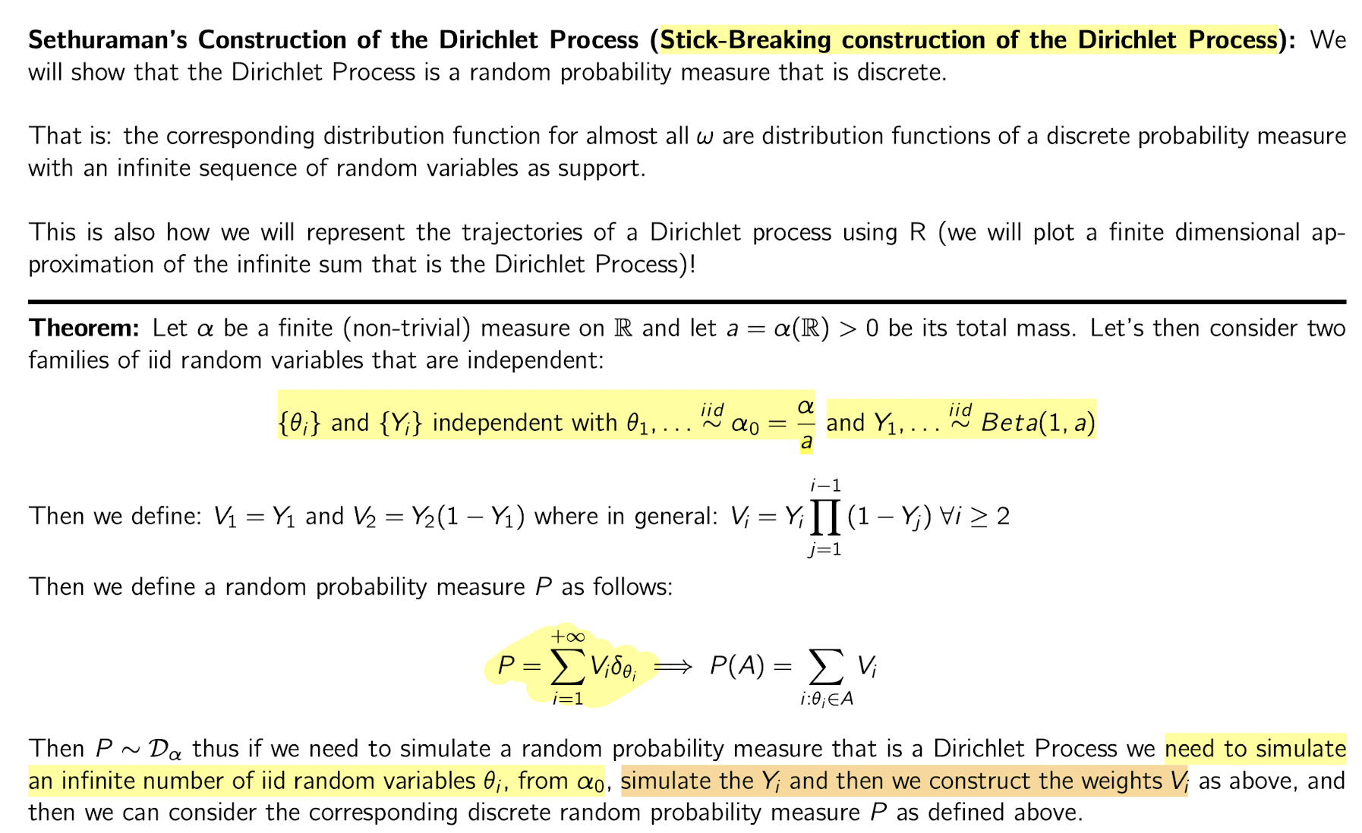

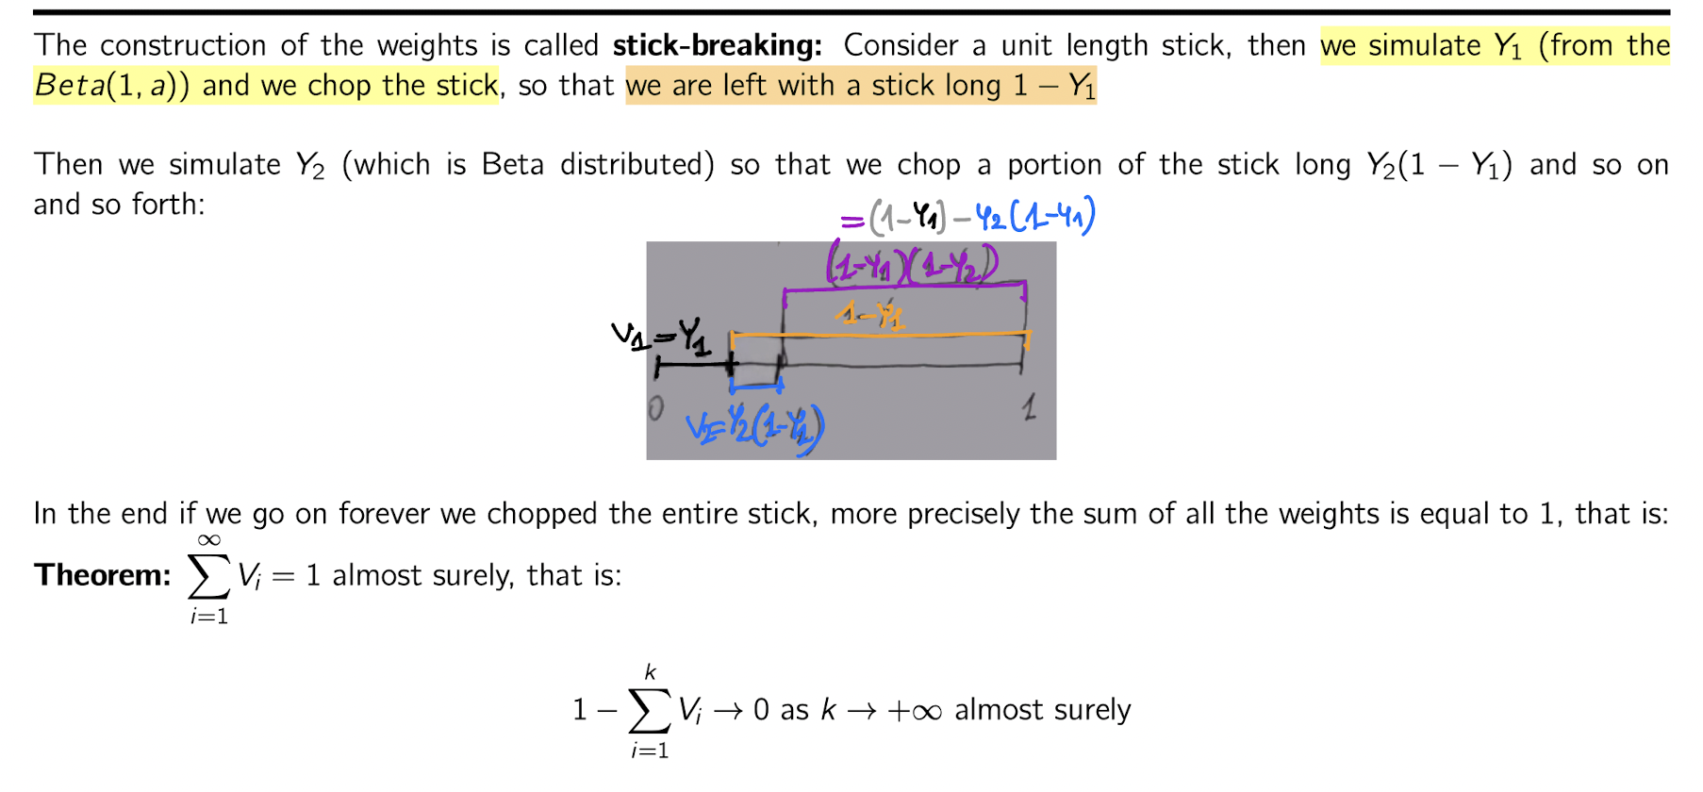

**Come simulare questa distribuzione? CRP**

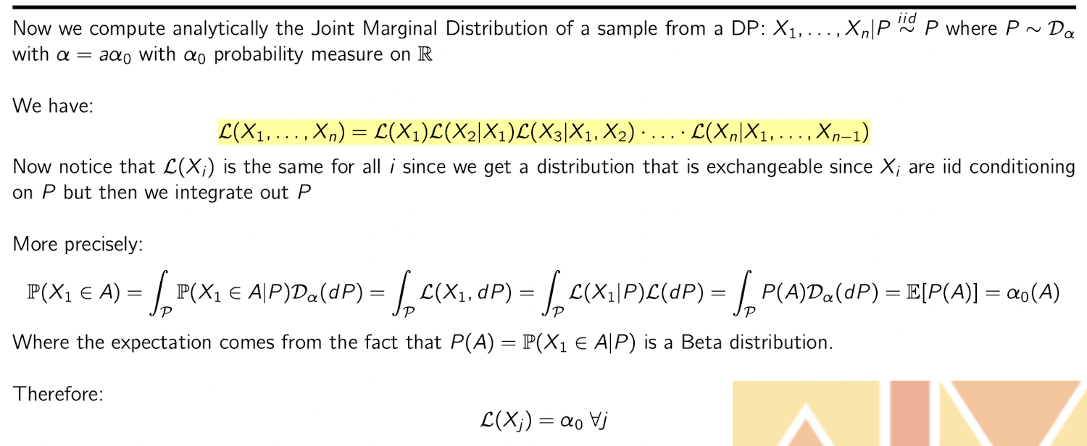

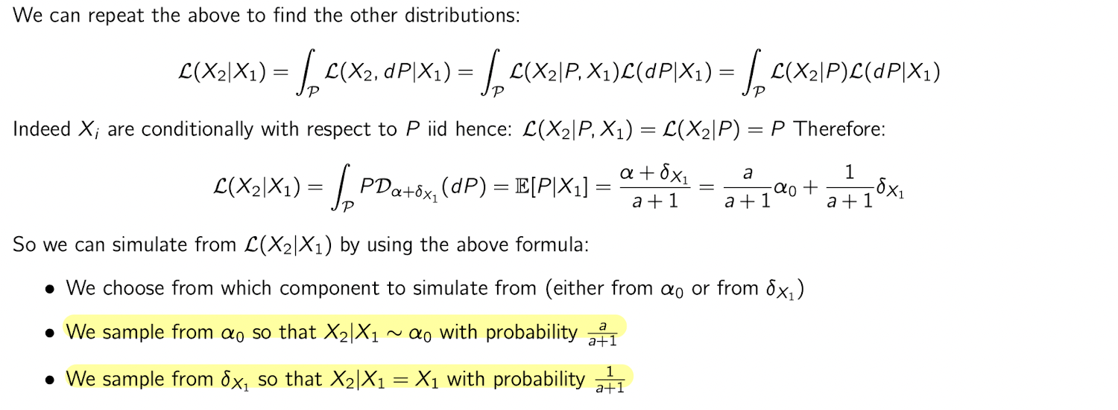

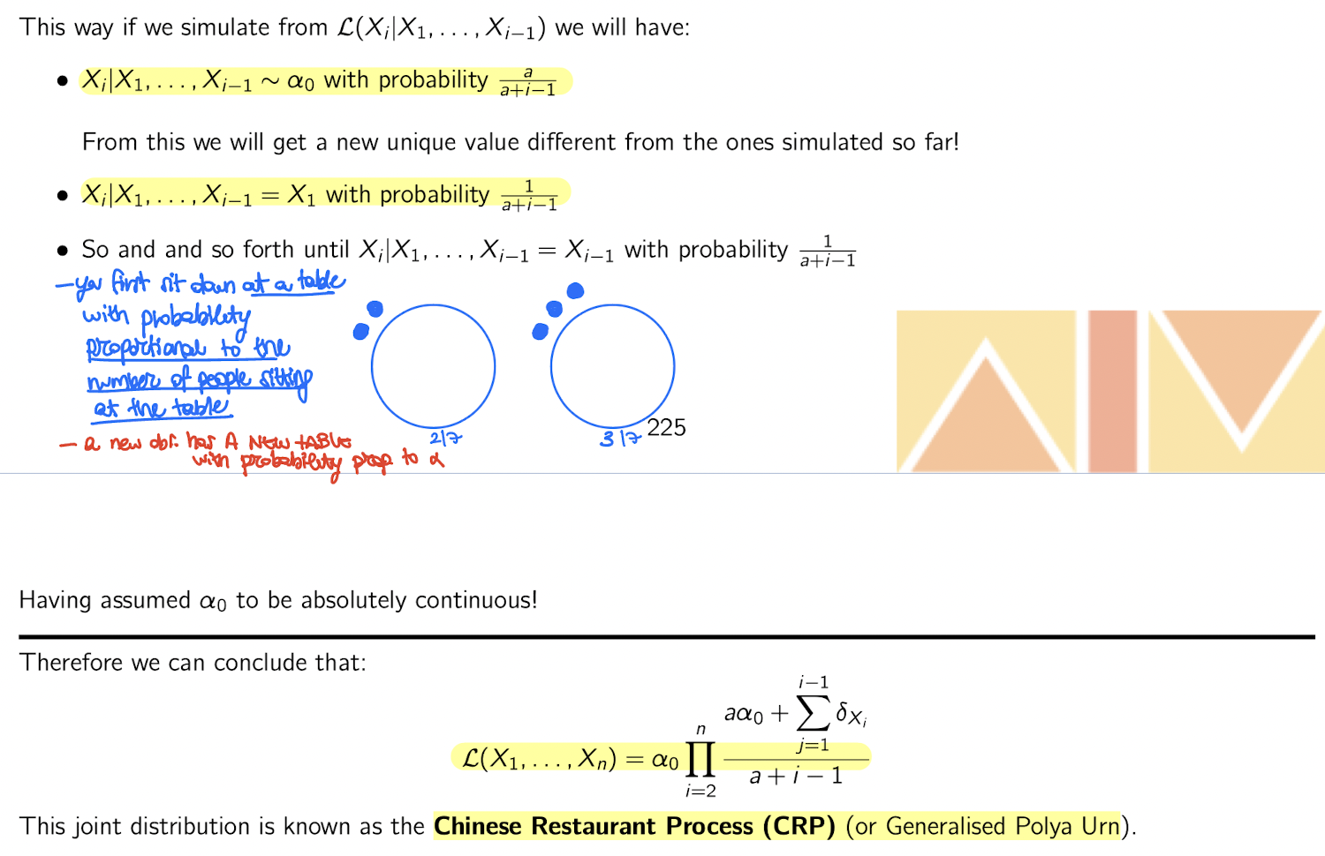

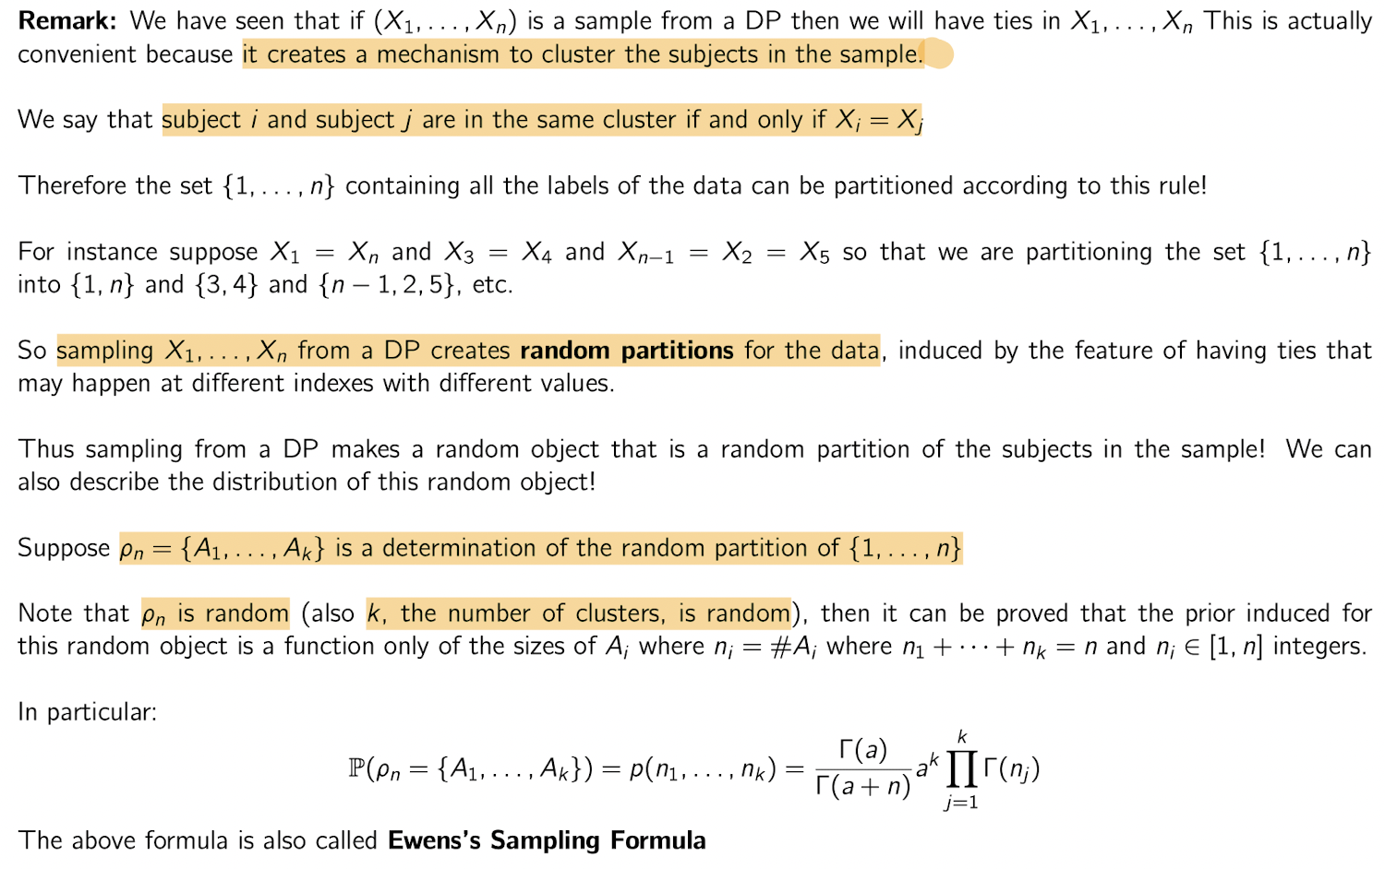

**Case study:** T-cells are white blood cells and are a critical part of the immune system. The experiment generates a random sample of T-cells from the population of all T-cells that are present in a probe. The sample is recorded by tabulating the counts $yi$ for all observed T-cell types, $i = 1, . . . , n$*. However,* ***some rare but present T-cell types****, $i = n+1, . . . , N$* , **might not be recorded**, simply by sampling variation, that is **when $yi = 0$ for a rare T-cell type**. Naturally, **zero counts are censored by the nature of the experiment**. Inference for **F(0) would allow us to impute the number of not observed zero counts and thus infer the total number of T-cell types**. The latter is an important characteristic of the strength of the immune system.

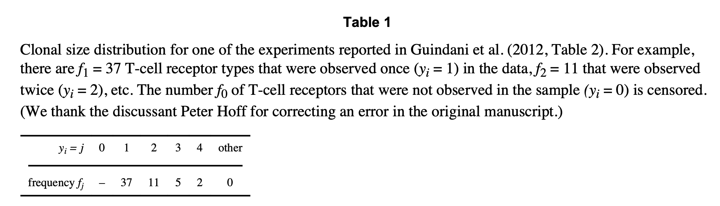

Figure 1 shows the empirical distribution 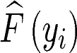together with a BNP estimate E(F | y). Inference on F (·) allows imputation of, the number of zero-censored T-cells. A parametric model $Fθ (y),$ like a simple Poisson model or a finite mixture of Poissons models would report misleadingly precise inference for $θ$– and thus $Fθ (0)$– based on the likelihood.

Guindani et al. (2012) use instead a **Dirichlet process (DP) mixture of Poisson model for F**. Figure 1b shows the posterior distribution $p(N | y)$ under the same model that was used for the posterior inference in Figure 1a.

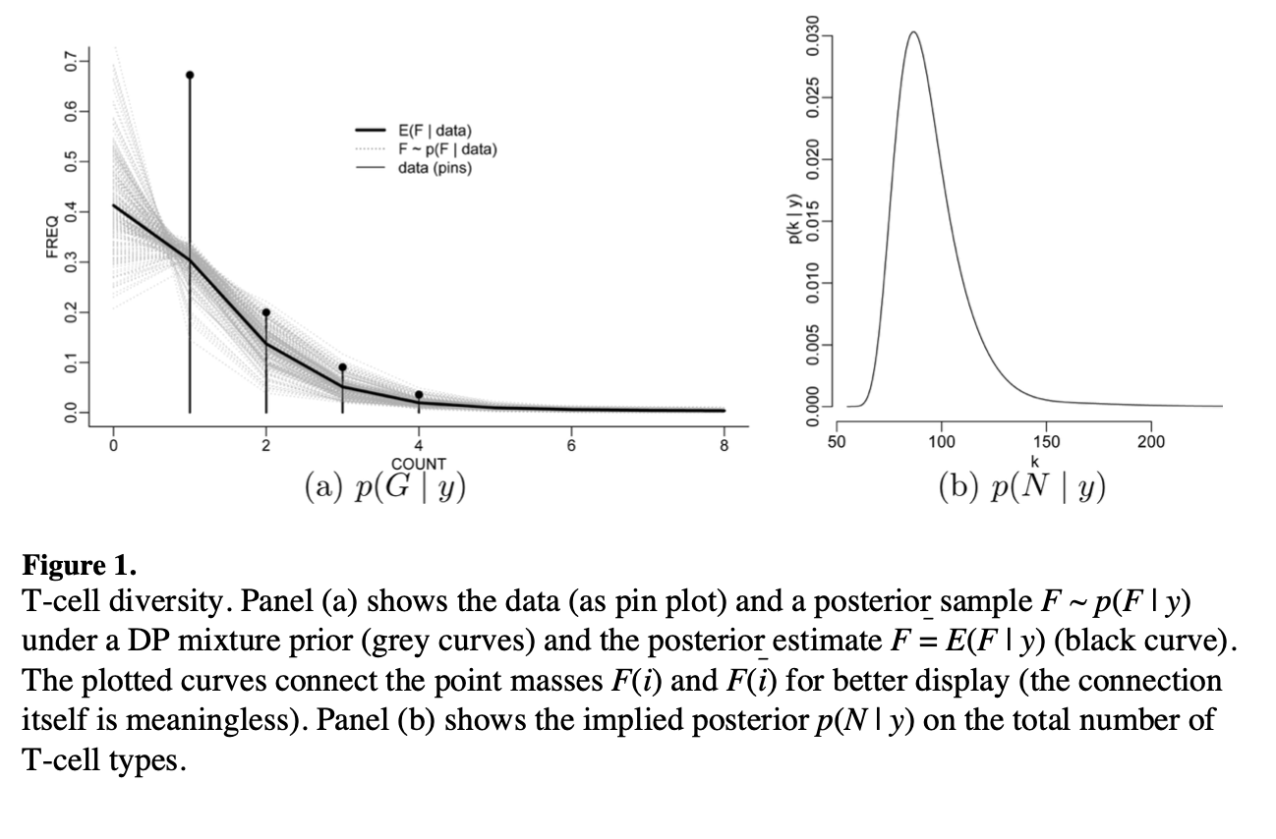

**Example (Guindani, 2012):** DPM model with $p\left(y | θ\right)=Poi\left(y,θ\right)$

**Key points:**

* $θ_{i}$ interpretable as mean abundance of T-cell type i.
* The Bayesian Non parametric model allowed the critical extrapolation to F(0) without relying on a particular parametric form of the extrapolation

## 2.2. Polya Tree Priors

An intuitively attractive way to construct RPMs is as a random histogram, with a fixed set of bins and random probability mass associated with each bin. Polya trees arise as an extension of this idea where the size of the bins is made sequentially smaller. Especially for univariate and low-dimensional distributions the Polya tree (PT) prior (Lavine 1992, 1994; Mauldin et al. 1992) is attractive. It requires no additional mixture to create absolutely continous probability measures.

**Construction.**

We start with the simplest histogram, with only two bins by splitting the sample space into two subintervals B0 and B1 and assigning random probability

$$Y_{0}=G\left(B_{0}\right)∼Be\left(a_{0},a_{1}\right)$$

$$Y_{1}=G\left(B_{1}\right)=1-Y_{0}$$

Next, we refine the histogram by splitting B0 in turn into two subintervals B00 and B01:

$Y_{00}=G\left(B_{00}|B_{0}\right)∼Be\left(a_{00},a_{01}\right)$ and $Y_{01}=1- Y_{00}$…

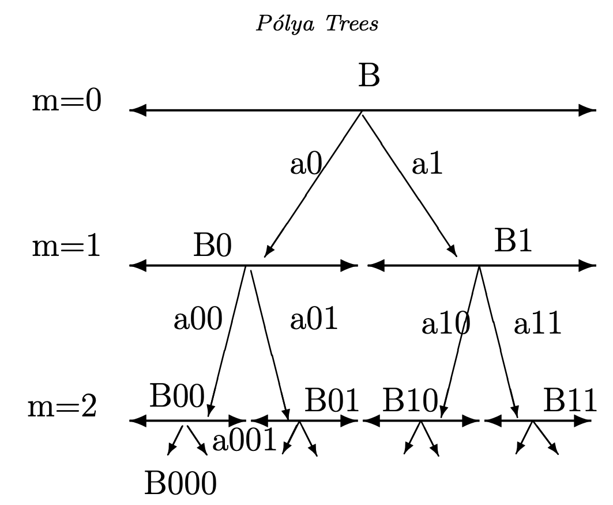

To summarize, we can define the random $G\left(B_{ϵ}\right)$ through a sequence of conditional probabilities:

$$G\left(B_{ϵ}\right)=\prod_{k=1}^{m}{ }G\left(B_{e_{1}⋯e_{k-1}e_{k}}∣B_{e_{1}⋯e_{k-1}}\right)$$

with the understanding that $B_{∅}$ denotes the entire sample space.

An RPM $p(G)$ is then defined by specifying a prior for the random splitting probabilities $Y_{ϵ}=$ $G\left(B_{ϵ0}∣B_{ϵ}\right)$ for any $m$-digit index $ϵ=e_{1}⋯e_{m},m>0$. The Pólya tree, in particular, assumes that $Y_{ϵ}∼Beta⁡\left(a_{ϵ0},a_{ϵ1}\right)$, independently across $m$. The PT can thus be characterized as a tail-free process with respect to a nested partition sequence $Π$ and beta distributed random splitting probabilities.

In summary, the $PT$ prior defines an RPM by assigning any partitioning subset $B_{ϵ}$ the random probability

$$G\left(B_{e_{1}⋯e_{m}}\right)=\underset{\text{all left splits }}{\underbrace{\prod_{43}^{m}{ } Y_{e_{1}⋯e_{j-1}0}}}\underset{\text{all right splits }}{\underbrace{j=\prod_{j;e_{j}=0}^{m}{ } \left(1-Y_{e_{1}⋯e_{j-1}0}\right)}},$$

**Example:** PT prior with G=Weibull distribution to model the distribution of time to progression (TTP) for prostate cancer patients.

### More Random probability measures are possible …

For example, CRM

## **Clustering**

### DP Partitions

